Chip back potential is the level which bulk silicon is maintained by on-chip connection, or it is the level to which the chip back must be connected when specifically stated below. If no potential is given the chip back should be isolated.

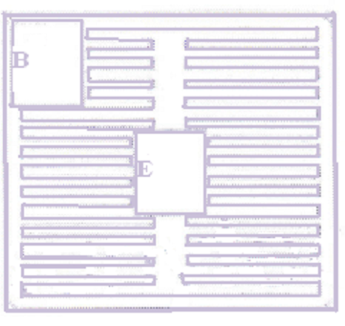

Top Material: Al
Backside Material: Ti Ni Ag
Bond Pad Size: .004” min
Backside Potential: Collector
Mask Ref: 003140

APPROVED BY:RB DIE SIZE: .100” X .100” DATE: 10/20/21
MFG: GENERAL SEMI THICKNESS: .015” P/N:2N4150
DG 10.1.2

Rev B, 7/19/02

